Instead of paper billing, you might consider using an online demographics/billing collection form. This will insure correct reconciliation between appointments billed and proper demographics if you build error checking into the form. It will also help with data analysis, since responses are usually stored in a spreadsheet that can be exported to Excel. Here is a sample of one such form using a relatively inexpensive service called JotForm.com.
https://form.jotform.com/ACMSIdaho/SamplePWPBilling

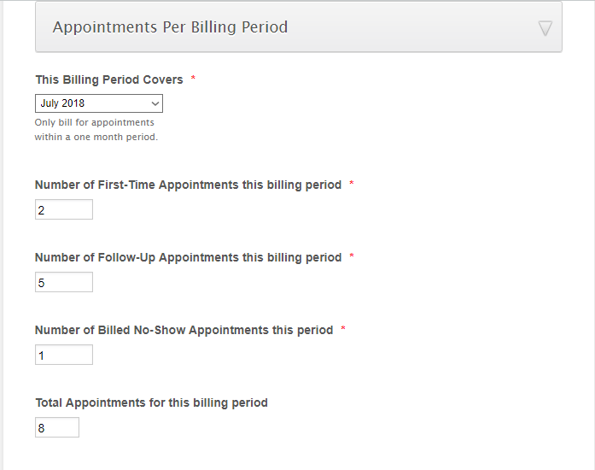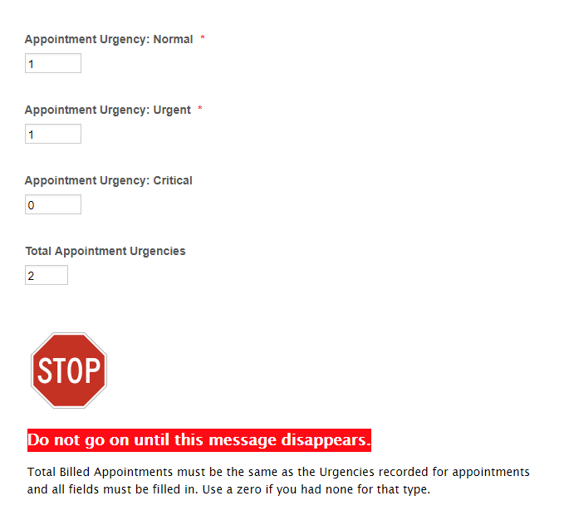
After completing the form, both the therapist and medical society will receive an email confirmation that can be used an invoice for bookkeeping records.
